# Lab 15: Throwing Exceptions

## Objective

In this lab, we will experiment with some of the basic coding involved with creating new exceptions and throwing and catching them.

## Overview

In this lab you will:

* Create a new exception.
* Write some code that throws the new exception
* Write some code that tries to execute the new code and handles the new exception.

## Step by Step Instructions

**Exercise 1: Creating an Exception**

An exception is typically just a marker class which means that we tell different exceptions apart simply by their name.

1. For this lab, we will work in the **ClassExercises** project and the **com.lq.exercises** package. Create a new exception class named **TooHotException**. Ensure that this new class extends **Exception**.

Your class should have two constructors (Default and accepts String message. Delete any others as we will not use them. Make sure you have the appropriate super calls in each.

1. Create another new class named **Coffee**. Add a method named setTemperature() that accepts one parameter of type int and returns a void. Also, add an attribute to the **Coffee** class of type int named temperature. Add a getTemperature() method that returns the contents of temperature.
2. In the body of the setTemperature() method, check to see if the temperature that was passed in is greater than 120 degrees. If it is, throw a new **TooHotException** back to the caller of the method with a message that the coffee is too hot.. Otherwise, set the temperature. Remember to add the throws declaration to your setTemperature() method.
3. Add a constructor to accept a temperature.
4. Create a new class named **CoffeeExerciser**. Ensure that it has a main() method. In the body of the main method, create a **Coffee** object with a value of 110. You will have to do this inside of a try block and will also need a catch block to deal with the possibility of the exception getting thrown. At the very end of the main() method, call getTemperature() and print out the value that it contains to ensure things are working well. Your main() method should look similar to the following. Run your program and observe the output.

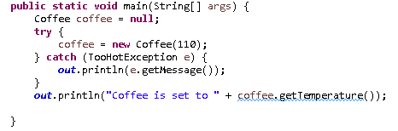

1. Let’s make a change so that we can see how finally blocks get processed. Move the print statement which is currently at the end of the main() method into a finally block. Re-run your program. Does the print statement still execute?

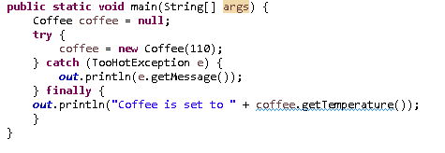

1. Now, change the temperature from 110 to 125. Re-run your program. What prints this time? It should look as follows:



Because an exception was thrown, we never actually created the Coffee object and set temperature to a new value. But we did execute the catch block and the finally block. And since the finally block used the coffee reference, which was never set up an instance due to the **TooHotException**, a **NullPointerException** was thrown.

This kind of logic error is very common. In fact, it has been latent in the code since Step 5 introduced the original version of main(). Tracking down the root causes of exceptions is important, as is proper exception handling to prevent exceptions from catastrophically cascading.

1. Challenge Exercise: Can you make it so that the **CoffeeExerciser** does not fail with an exception, but rather reports that the temperature is 0, *i.e.*,



Hint: there are at least four different ways to make that happen.